**Module – 2**

**Name: Nukala Ayyappa Bharthwaj**

**Batch Id: DSWDMCOS 21012022**

**Problem 1:** Import the given dataset and check for ‘NA’ values in it using the appropriate function. Now follow the given steps to manipulate your data:

Note: - **Use Data Manipulation Dataset.**

1. Create a new data frame using the given data frame (i.e. the given dataset) by removing the ‘NA’ values.
2. Consider the given dataset to replace the first NA value in the dataset with your name in that place.
3. Find the factor of each column in the dataset
4. Find the class of each column in the dataset
5. Find the structure and summary of the dataset.

Ans: All the above operations are done for the given data set using R Programming and the same is attached.

**Problem 2:** Use R to create the following two matrices and do the indicated matrix multiplication**.**



**Ans:** I have created the above matrices and multiplication operation of matrices is also done using R Programming and the same is attached.

**Problem 3:** Use R to create the following two matrices and multiply each value to its successive position.

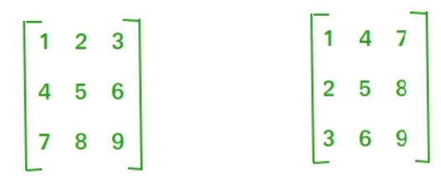

**Ans:** The above question is done by using R Programing and the same is attached.

**Note:** Use R to solve the given problems in the above.